The Marriage of
Insert Name

&

Insert Name

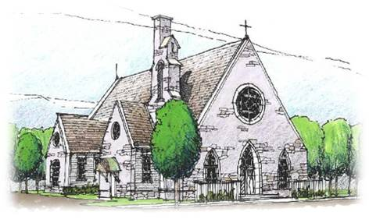

05th December 2013
at 2.30pm

St Mary’s Church

-------------Inside front cover-------------

Bride

Groom

Chief Bridesmaid

Best Man

Bridesmaids

Flowergirls

Ushers

Bride’s Parents

Groom’s Parents
ENTRANCE OF THE BRIDE
Canon in D Major by Johann Pachelbel

WELCOME

by Reverend Alan

HYMN

Make me a channel of your peace.
Where there is hatred let me bring your love;
Where there is injury your pardon, Lord;
And where there's doubt true faith in you.
Refrain:
Oh, Master grant that I may never seek
So much to be consoled as to console;
To be understood as to understand;
To be loved as to love with all my soul.
Make me a channel of your peace.
Where there's despair in life let me bring hope;
Where there is darkness, only light;
And where there's sadness, ever joy.
Refrain
Make me a channel of your peace.
It is in pardoning that we are pardoned;
In giving to all men that we receive;
And in dying that we're born to eternal life.
Refrain

READING
From the Letter of St Paul to the Romans 12: 1-2.9-18
Read by

RESPONSORIAL PSALM
Psalm 102: 1-2.8.13.17-18
Sung by the Soloists

GOSPEL READING
John 15:12-16

HOMILY

READING
“The Best is Yet to be”
read by

THE RITE OF MARRIAGE

PRAYERS OF THE FAITHFUL
Read by

HYMN

As I kneel before you,
As I bow my head in prayer,
Take this day, make it yours
and fill me with your love.
Refrain: Ave Maria,
Gratia plena,
Dominus tecum,
Benedicta tu.
All I have I give you,
Every dream and wish are yours,
Mother of Christ,
Mother of mine, present them to my Lord.
(Repeat Refrain)
As I kneel before you,
And I see your smiling face,
Ev'ry thought, ev'ry word
Is lost in your embrace.
(Repeat Refrain)

THE LORD’S PRAYER

HOLY COMMUNION

THE CONCLUDING RITE
HYMN

And did those feet in ancient time
Walk upon England's mountain green?
And was the holy Lamb of God
On England's pleasant pastures seen?
And did the countenance divine
Shine forth upon our clouded hills?
And was Jerusalem builded here
Among those dark satanic mills?
Bring me my bow of burning gold!
Bring me my arrows of desire!
Bring me my spear! O clouds, unfold!
Bring me my chariot of fire!
I will not cease from mental fight,
Nor shall my sword sleep in my hand,
Till we have built Jerusalem
In England's green and pleasant land.

SIGNING OF THE REGISTER

Witnessed by

PROCESSION OF THE WEDDING PARTY

Wedding March: Mendelssohn

-------------Inside back cover-------------



The Bride and Groom would like to pay a special thank you to
St Mary’s Church, to the Reverend, the Organist,
and the Bell ringers.

We would also like to thank our close family and friends, for travelling the distance to join us in our marriage
celebration.

